Video Notes #2 - Matter
Objective 7: I can define atoms, matter, and elements.
– tiny particles that make up part of an element, which is made up of protons, neutrons and electrons. All atoms of the same element have the same .
Matter – Anything that has mass and takes up space.
Elements – a that is only made up of one atom.
Objective 8: I can explain the properties of atoms.
All atoms of the same have the same properties.
Example:
Iron atoms: All iron atoms have the same mass and occupy the same amount of space!
Objective 9: I can describe Elements and how they are organized.
Anything made of just kind of atom is called an Element!
Elements cannot be broken down into other substances!
There are elements that combine in a lot of ways that make up all and things.
Objective 10: I can describe matter and how it is classified.
Matter is composed of extremely tiny particles called .
These particles are too to be seen with .
Atoms have all the properties of matter: and .
can be classified into two general categories: and pure substances.
: Consists of two or more substances that are together but not chemically .
Pure substances: are made of only one kind of matter and has .
Objective 11: I can define and explain the states of matter.
, , and are four states of matter. We will only focus on the first three!
SOLIDS:
- Particles of solids are tightly , vibrating about a fixed position.
- Solids have a shape and a definite .
LIQUID:
- Particles of are tightly packed, but are far enough apart to slide over one another.
- Liquids have an shape and a volume.
GAS:
- Particles of are very far apart and move .
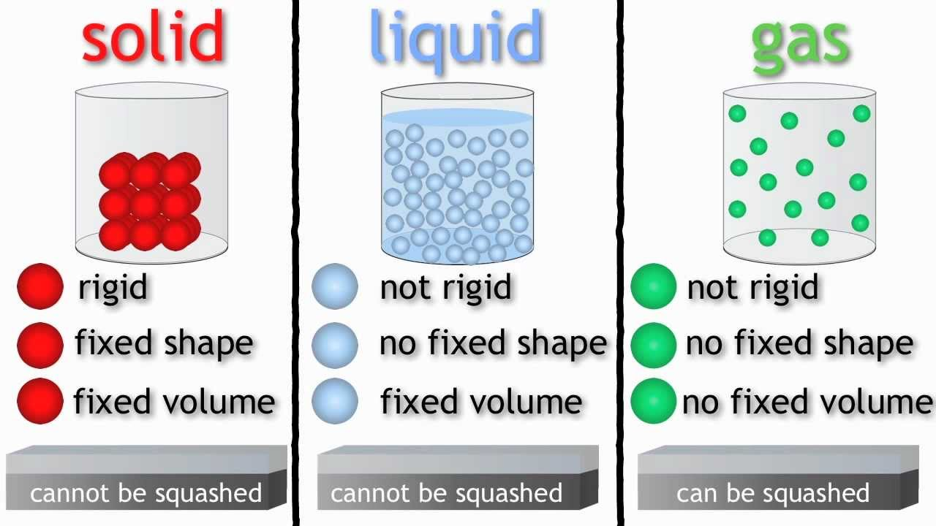
- Gases have an shape and an volume.

